1. Use case diagram

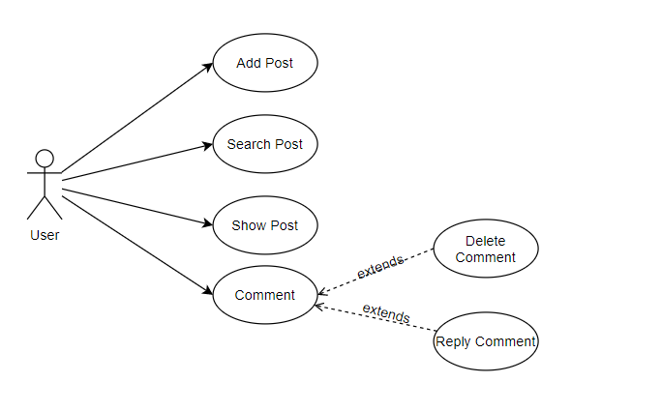

Use Case List

|  |  |
| --- | --- |
| ID | Use Case |
| UC – 1 | Comment |
| UC – 2 | Reply Comment |
| UC – 3 | Delete Commnet |
| UC – 4 | Search Post |
| UC – 5 | Add Post |
|  |  |

1. UC – 1: Comment

|  |  |  |  |
| --- | --- | --- | --- |
| ID and Name: | Comment | | |
| Created By: | Nguyen Huu Lam Phong | Date Created: | 4/9/2021 |
| Primary Actor: | Leaner, Mentor,Manager | Secondary Actors: | N/A |
| Description: | User comments to evaluate the post. | | |
| Trigger: | User fill in comment input and click “Bình luận” to send comments | | |
| Preconditions: | N/A | | |
| Post-conditions: | Add successful comments to the Post | | |
| Normal Flow: | 1. User accesses to the Post 2. User comments to the Post  3. User enters of click to “Bình luận” to complete this comments 4. The system displays comment of user | | |
| Alternative Flows: | N/A | | |
| Exceptions: | 2.a. If not invalid any information will be display prompt. Go to step 2 of Normal flow | | |
| Priority: | Medium | | |
| Frequency of Use: | Medium | | |
| Business Rules: | N/A | | |
| Other Information: | N/A | | |
| Assumptions: | N/A | | |

1. UC2 – Reply Comment

|  |  |  |  |
| --- | --- | --- | --- |
| ID and Name: | Reply Comment | | |
| Created By: | Nguyen Huu Lam Phong | Date Created: | 4/9/2021 |
| Primary Actor: | Leaner, Mentor,Manager | Secondary Actors: | N/A |
| Description: | User reply the comments in the post | | |
| Trigger: | User wants to reply comment to the post | | |
| Preconditions: | N/A | | |
| Post-conditions: | Reply successful comments to the Post | | |
| Normal Flow: | 1.User accesses to the Post  2.User click to “Phản hồi”  3.User reply to the comments and enters of click to “Bình luận” to complete this comments  4.The system displays comment of user | | |
| Alternative Flows: | N/A | | |
| Exceptions: | 2.a. If not invalid any information will be display prompt. Go to step 2 of Normal flow | | |
| Priority: | Medium | | |
| Frequency of Use: | Medium | | |
| Business Rules: | N/A | | |
| Other Information: | N/A | | |
| Assumptions: | N/A | | |

1. UC3 – Delete Comment

|  |  |  |  |
| --- | --- | --- | --- |
| ID and Name: | Delete Comment | | |
| Created By: | Nguyen Huu Lam Phong | Date Created: | 4/9/2021 |
| Primary Actor: | Leaner, Mentor,Manager | Secondary Actors: | N/A |
| Description: | User delete the comments of them in the post | | |
| Trigger: | User to delete the comment of them the post | | |
| Preconditions: | N/A | | |
| Post-conditions: | Delete successful comments to the Post | | |
| Normal Flow: | 1.User accesses to the Post  2.User click to “xoá” under the comments of them  3.The system display the dialog to confirm  4.a. User click “Xác nhận”  5.a. System delete the commets  4.b. User click “Huỷ”  5.b. System go to step 1 | | |
| Alternative Flows: | N/A | | |
| Exceptions: | 2.a. If not invalid any information will be display prompt. Go to step 1 of Normal flow | | |
| Priority: | Medium | | |
| Frequency of Use: | Medium | | |
| Business Rules: | N/A | | |
| Other Information: | N/A | | |
| Assumptions: | N/A | | |

1. UC4 – Search Post

|  |  |  |  |
| --- | --- | --- | --- |
| ID and Name: | Search Post | | |
| Created By: | Nguyen Huu Lam Phong | Date Created: | 4/9/2021 |
| Primary Actor: | Leaner, Mentor,Manager | Secondary Actors: | N/A |
| Description: | User want to search the Post in all Post | | |
| Trigger: | User use the search bar | | |
| Preconditions: | N/A | | |
| Post-conditions: | Search successful Post | | |
| Normal Flow: | 1.User accesses the search bar  2.User fills in the search bar  3.User click the button “Tìm kiếm”  4. The system searches for posts with keywords similar to those in the search bar | | |
| Alternative Flows: | N/A | | |
| Exceptions: | 2.a. If not invalid any information will be display prompt. Go to step 2 of Normal flow | | |
| Priority: | Medium | | |
| Frequency of Use: | Medium | | |
| Business Rules: | N/A | | |
| Other Information: | N/A | | |
| Assumptions: | N/A | | |

1. UC5 – Add Post

|  |  |  |  |
| --- | --- | --- | --- |
| ID and Name: | Add Post | | |
| Created By: | Nguyen Huu Lam Phong | Date Created: | 4/9/2021 |
| Primary Actor: | Leaner, Mentor,Manager | Secondary Actors: | N/A |
| Description: | User want to add new post | | |
| Trigger: | User click the “Add” to move to add post screen | | |
| Preconditions: | N/A | | |
| Post-conditions: | Add the Post successfully | | |
| Normal Flow: | 1.User click to button “Add”  2.User fills the content in text Area  3.User click the button “Add”  4. The system add the posts to database and show the post in the show Post screen | | |
| Alternative Flows: | N/A | | |
| Exceptions: | 2.a. If not invalid any information will be display prompt. Go to step 2 of Normal flow | | |
| Priority: | Medium | | |
| Frequency of Use: | Medium | | |
| Business Rules: | N/A | | |
| Other Information: | N/A | | |
| Assumptions: | N/A | | |

1. System Funtion Overview
2. Screen flow

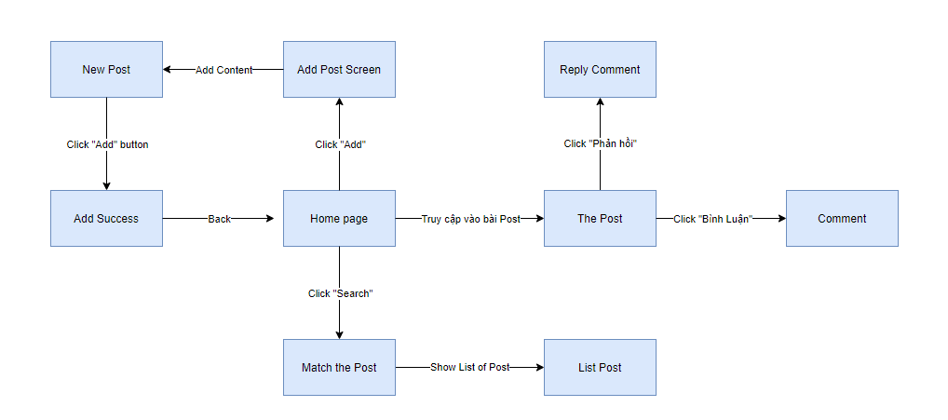

1. Screen Detail

|  |  |  |  |
| --- | --- | --- | --- |
| **#** | Feature | Screen | Description |
| 1 | View Post | Home Screen | Show 10 new post |
| 2 | Search & Filter Post | Home Screen | Search and filter Post by search bar |
| 3 | Comment | Home Screen | Comment in the Post |
| 4 | Reply Comment | Home Screen | Reply another comment |
| 5 | Delete Comment | Home Screen | User delete comment of them |
| 6 | Add Post | Add Screen | User add new post in the page |

1. ERD Diagram

